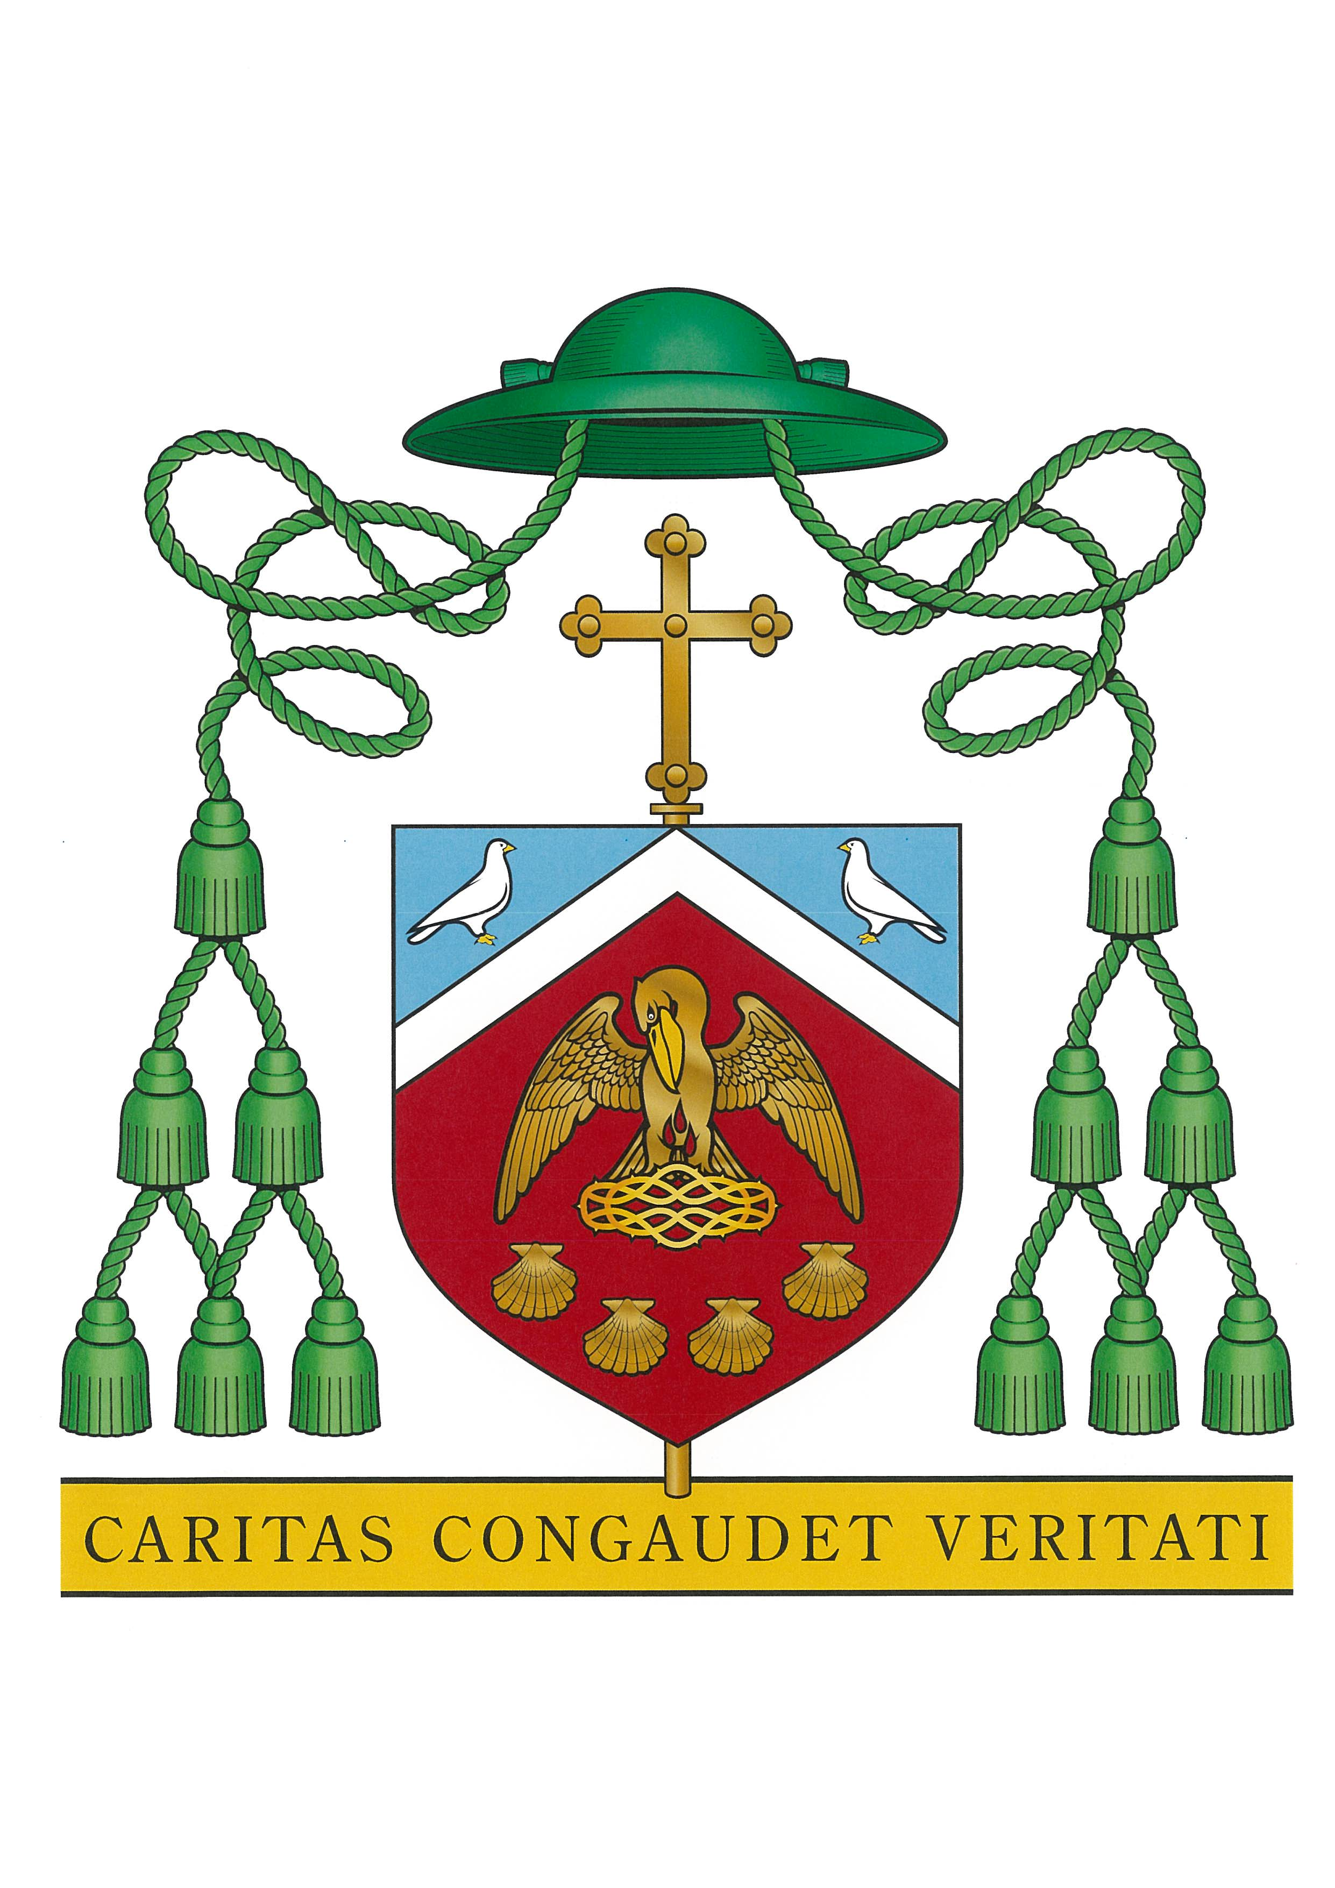

New Zealand Catholic Bishops Conference
Preference of Enrolment Certificate
for the
Diocese of Palmerston North

This is to certify that In accordance with Private Schools’ Conditional Integration Act, Section 29(1), and Catholic School Integration Agreements, through a general or particular religious connection as stated in the Preference Criteria Numbers 5.1, 5.2, 5.3, 5.4, 5.5.

(Please refer to Criteria details on back of form)

MR/MRS/MS
Address
Is/are eligible to have preference of enrolment for their child at
School/College
in Town/City

Name of child
I/We undertake to support our child in the formation of their faith and the practices of the Catholic church.
Parent(s)/Caregivers Signature Date

Under which Criterion (see reverse) is the child eligible for preference?..................................
If Criterion 5.1 applies please complete:

Baptised in at on
If Criterion 5.4 applies please complete the section on the back of this form.

Certified by (Name): as authorized agent of the
Roman Catholic Bishop of the Diocese of
Position:
(see: Administration of the Criteria, 6.1.1-6.1.6, Agents who may sign, listed over page)
Address:
Signature Date

This form must be completed by the Parent(s)/Caregiver(s), and the Parish Priest or other designated authorities prior to the enrolment of a student in a Catholic Integrated School.
PTO
2009 Version
NEW ZEALAND CATHOLIC BISHOPS’ CONFERENCE

Criteria for Preference of Enrolment in Integrated Catholic Schools
  - The child has been baptised or is being prepared for baptism in the Catholic Church.

  - The child’s parents/guardians have already allowed one or more of its siblings to be baptised in the Catholic faith.

  - At least one parent/guardian is a Catholic, and although their child has not yet been baptised, the child’s participation in the life of the school could lead to the parents having the child baptised.

  - With the agreement of the child’s parent/guardian, a grandparent or other significant adult in the child’s life, such as an aunt, uncle or godparent, undertakes to support the child’s formation in the faith and practices of the Catholic Church.

  - One or both of a child’s non-Catholic parents/guardians is preparing to become a Catholic.

Agents of the Bishop, Who May Sign the Certificate on his Behalf
    - Parish Priest of their Parish of Residence
    - Assistant Priest of their Parish of Residence
    - Priests appointed under c. 517/1
    - Deacons and lay persons appointed to pastoral care under c. 517/2
    - Ethnic chaplains who liaise with parish priests or their delegate
    - Local committees appointed by the Bishop or by any of the above agents of the Bishop.

Process of Appeal
Handbook for Boards of Trustees of New Zealand Catholic Integrated Schools.
    - If a preference certificate has been refused and the parents, either directly or through the Principal, wish to appeal the matter, the application can be referred to the proprietors’ Office (Diocesan Education Office). The Director of the Office, or whoever is the appointed appeal authority in the diocese, after making whatever investigation is necessary, including consulting the parish priest if appropriate, will make a ruling, or seek a ruling from the Bishop. The parish priest or delegated person who refused the certificate in the first instance is normally informed whenever a preference certificate is issued in virtue of this paragraph.

Please note that in the Diocese of Palmerston North the appointed appeal authority is the Manager for Schools (Mrs Lynette Roberts-King). Contact Ph: 06 354 1780 (Ext 853 ).

If Criterion 5.4 (above) applies the parents/caregivers and significant adult completes the following:
Significant adult:
I agree to support (child’s name)
formation in the faith and practices of the Catholic Church.
Mr/Mrs/Ms:
Address:
Relationship to child:
Signature Date:
Parish
Parent(s)/Caregiver(s):
I agree that my child will be supported by in the formation of the faith and practices of the Catholic Church.
Signature: Date:

